EECE 5698
LAB 3

Shreyash Jadhav

I had injected 0x25(37) as the fault in the original state.
For the first {C,F} pair the following is the delta values:
4,28,31,37,44,100,112

For the second {C,F} pair the following are the delta values:
37,40,42,55,62,114

From the two runs we get 37 are the unique delta.

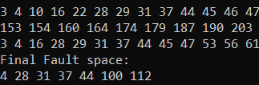

First Run of the {C,F} pair
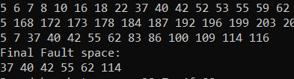

Second Run of {C,F} pair
Retrieved Last Round Key:
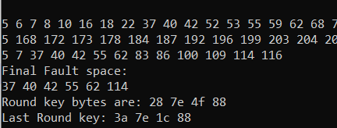

Was able to retrieve 2 correct bytes from the last round. Tried different approaches to get all the four bytes but did not get the other two bytes.

